Date: 04/06/2016

HND Software Development: F48W35 Graded Unit  
  
Simply Rugby Application Project Evaluation Report  
 Period covered from 25/01/2016 to 23/05/2016

Author: Michal Bochenek Student ID: EC1401916  
 Assessors:  
 Sharon Martin & Duncan Walker

Contents

1. Introduction. 3

2. Background information about the application. 3

3. Project design process evaluation. 4

4. Project implementation process and its output evaluation. 6

5. Strengths and weaknesses assessment on the outputs of the practical assignment (application). 8

5.1. A user questionnaire and feedback results. 8

5.2. Strengths. 9

5.3. Weaknesses. 9

6. Future development recommendations. 10

7. Design and prototype modifications summary. 11

8. Knowledge and skills gained by the student. 14

9. Project plan execution evaluation. 15

# Introduction.

This document was created by the application designer who took the role of a critic for the purpose of the evaluation of the Simply Rugby application project plan and its execution.   
It contains designer opinions and thoughts on the project, user feedback and planning, design, implementation, testing and documentation realisation rating.   
This report is targeted to anyone who is going to create a software development or wants to review the existing project, how it was carried on by the student who did such an undertaking for the first time, also this is a valuable summary of the achievements, assessment on strengths and weaknesses and important findings discovered while the project next steps were being done.  
Based on this evaluation it can be pointed out in which direction the future development should be carried towards to, and how the process could be improved and what new tools or best practices should be taken into consideration.

# Background information about the application.

In the graded unit scenario a Simply Rugby sport club was looking for a skilled software developer which would be able to create an application for managing the club membership structure and documentation containing each member personal data (i.e. contact details, insurance status, health issues etc.), games record, training activities, player skills and make the administration be able to communicate with the other club members and estimate player development routes and best position to be played based on his previous achievements and skills.  
After the brief with the client and analysis of the existing solutions a number of additional functionalities was identified such as the need for security of the data, creating a different account types, accessibility of the application on the mobile devices and ease of learning and use for non-expert users.  
The application will be used by the club coaches, administration members and players in various ways with the biggest emphasis on coaches, as they are looking forward to use most of the features and functions of this software.

# Project design process evaluation.

It is important to think wide and thorough when designing an application, as this is the base-ground on which the whole project will be built, it costs nearly nothing to change the idea while designing an application and therefore one can avoid number of problems in the future and correct any missing details or errors found early on, that’s one of the most important findings discovered for this project.  
  
In this paragraph an overview of the designers approach on how to create a functional and user-friendly design in a number of steps undertaken was shown:  
  
**a) Carry an interview with the client:**  
While the clients initial brief gave a basic understanding of the clients expectations it also created a number of questions on specifying what does the client actually needs, thus an interview with prepared list of questions is a priority before even starting to work on the design.  
  
**b) Research potential user opinions and expectations:**A group of people were asked to take a role of a club member and answer the question form created by the developer in which some basic questions about the features were put and how would they see the application user interface design structure. This is one of the efficient and effective approaches which can be taken when looking for others opinions on the design matter, different ways could be brain-storming or one-on-one interviewing.  
It gave a unique insight to the other people way of thinking which induced the creativity of the designer and gave him valuable tips for the future prototyping.  
  
**c) Check for existing solutions:**  
It rarely happens that some projects are fully innovative and not already featured in others designs, such an research was an important point of this project stage as the designer ideas could be compared to others solutions and portions of them could be implemented and tailored to the customers needs.

**d) Create an initial top level use case model:**  
Based on the gathered data an initial use case model was created and it was used later to build the business and view model on which the working prototype was made.  
  
**e) List all resources, materials and skills required:**Before beginning to work on the prototype its worthwhile to check to which resources and materials the designer has an access already to and which are need to be planned to obtain in order to avoid delays caused by the resource, time or personnel shortage and the whole project plan has to be based on realistic capabilities, “think big but act small” rule applies to it perfectly.  
  
**f) Documentation:**  
Once the initial ideas were gathered it was necessary to create a consistent documentation and to put all the findings in there as a requirements specification.  
  
In the end this process following the above rules was carried out very fluently and exhaustively in the project and it allowed the developer to proceed to the implementation stage without much delay and the need to return to it at the later stages.

# Project implementation process and its output evaluation.

Implementation stage begun after creating initial top level use case model which summarised the client needs and the designer capabilities. It was necessary to specify the model before prototyping it with the use of business and the view model which was included in the project documentation.  
To schedule and predict the workload in the project a user interface wireframe, database and website back-end logic containing: scripting, user access and interaction between subsystems was modelled.   
Thanks to which the implementation output was produced quickly and efficiently as the whole coding process took about 40 – 50 working hours.  
The project was implemented with the use of resources specified in the requirements specification document to meet the client needs.   
According to the aforementioned document the requirements were gathered and are displayed in the table below with estimated percentage of how much they were met in the presented application.

|  |  |  |
| --- | --- | --- |
| Required feature: | Implementation result [%]: | Commentary: |
| Registering a new club member | 100 | A secretary/administrator can register new member and give him/her login credentials. |
| Managing member personal details | 100 | Non-player member can edit specified users data. Players can view the data only. |
| Storing training session details | 100 | Data is stored and displayed with use of HTML5 forms. |
| Storing game details | 100 | Data is stored and displayed with use of HTML5 forms. |
| Creating future game fixtures | 100 | Data is stored and displayed with use of HTML5 forms. |
| Messaging system | 100 | Data is stored and displayed with use of HTML5 forms. |
| Ensuring safe access and different user access levels | 100 | There are 3 main types of user access levels: player, coach and administrator.  Passwords are encrypted once they are created with use of PHP blowfish algorithm. |
| Storing player member skills and positions played | 100 | Data is stored and displayed with use of HTML5 forms. |
| Mobile and stationary access to application | 100 | Using bootstrap framework allowed the page to scale depending on device screen size. |
| Interface based on forms and inputs | 100 | HTML5 forms, inputs and buttons were utilised to minimize the need for typing as much as it was possible. |

From this table it can be seen that the application does exactly what client required, based on the brief, from the developer, although after development stage was completed it was discovered that there is much room for improvement which was limited by the project time, budget and resource constraints triangle, still the project execution can be said that it was completed successfully.

# Strengths and weaknesses assessment on the outputs of the practical assignment (application).

## A user questionnaire and feedback results.

A group of people known to the developer, some of which were taking part in the first questionnaire about the design, was presented with the completed application and later on they were asked individually about their thoughts and opinions in a short questionnaire. The questions were given as a list below and answers are presented on the graphs, each question had a punctuation between 0 to 5 in which 5 is the best and 0 the worst.  
  
**Questions which were asked:**1. How much do you like the design and page layout?  
2. Would you say that the website colour palette is eye-friendly?  
3. Do you find the website easy to use and navigate?  
4. Do you find the website functions easy to learn and understand?  
5. Is the registration/login process is clear and understandable?  
6. Does the program meet its purpose, in your opinion?  
7. Does the program give useful user feedback (errors, successful data insertion etc.)?  
  
Answers given are shown on the diagram below each answer shows the total sum of points, 9 people were answering the questions thus maximum score is 45/45 and minimum is 0/45 for each question.

## Strengths.

Definitely the main advantage of the project is that the users find it easy to learn on how to use the application, and the program gives a useful feedback in form of alerts and warnings or on screen instructions to the users.  
Another strong side of this assignment is that the application met the client requirements, according to the opinions, and it is easy to navigate through the menu panel.

## Weaknesses.

The main issue found by the user feedback reported that the application might need some graphical improvement to better distinguish the elements one from another and mark out the more important ones with for example bold text font or different colours.  
The layout structure of the application scored less points as the questioned users found it that the forms and menu options are quite similar to each other and it could be problematic to quickly find out if the user has chosen the right option at the first look.

# Future development recommendations.

The modular design of the prototype which separates the user interface from the back-end scripting of the application allows it to develop it further in the future and add or modify existing features, if given the resources.  
  
The first proposed feature would be replacing some of the PHP server side validation in forms with the JavaScript as this would take the burden from the server side and limit the transferred data from and onto a server.   
  
Another useful feature would be improving the graphical layout as the user feedback suggested, to create visually attractive pages and put more pressure on the user work ergonomics.  
  
The application already contains forms and they are available to the users for viewing and editing, but it would be worth considering adding more interactive features which were out of the scope of the current project such as: rugby field on which coach could assign players to their best played positions suggested by the application algorithm, and create the whole squads based on the player skills.  
  
Coaches were also looking for a way to decide on which player skills should be trained and which players are to be put on a professional development path such a feature could be realised with addition of smart scripting which would track players progress and report on it to the coach in form of diagram.  
  
Furthermore to reduce the need of typing the text auto-filling could be improved or replace some inputs with filled-in choice lists.   
  
Lastly, adding an offline database for the application which would synchronise with the server database after establishing the connection could greatly improve the usability for the coaches when their team is playing in away location.

# Design and prototype modifications summary.

Despite time and resources used during the designing stage it was discovered that some features required modification or addition to the prototype.  
  
Initial top level use case model assumed that the administrator member will have all rights to view, create and modify the data records but in fact the majority of the features are being used by coaches, so these rights were removed to not overlap with the coach account type. This is making more sense as the administration member doesn’t need to view player profiles or remove training profiles, these are example options and they should be available to the coaches only to avoid causing chaos in the management system.

|  |  |  |  |
| --- | --- | --- | --- |
| **Old administrator account type** | **New administrator account type** | **Old coach account type** | **New coach account type** |
| View/Edit: - Personal Data - Fees and consents form  - Communications - Game record - Player Profile - Training Profile | View/Edit: - Member form - Fees and consents form - Communications | View/Edit: - Personal Data  - Communications - Game record - Player Profile - Training Profile | View: - Communications View/Edit: - Player profile - Training profile - Game record |

Additionally a player account type was updated and an ability to view the insurance status and parental consents for junior players was added.  
The non-player member account was removed as it didn’t require implementation in the current system requirements, although it might be returned in the future as an account type for the club fans or press etc.  
  
  
  
During the prototyping a missing database record was added to the business model which was necessary to manage the squads and coaches assigned to them:

|  |  |  |  |
| --- | --- | --- | --- |
| Record name: | Squads | | |
| Database name: | SRDB | | |
| Description: | Stores squad IDs, responsible coach ID, and squad internal name | | |
| Key attribute: | Attribute name | Type | Commentary |
| PK | ID | Int | Auto increment, NOT NULL |
|  | Squad_id | Int | Null |
|  | Squad_name | Varchar(20) | Null |
|  | Coach_id | Int | Null |

And messaging system to be effectively implemented had to be also added:

|  |  |  |  |
| --- | --- | --- | --- |
| Record name: | Messenger | | |
| Database name: | SRDB | | |
| Description: | Stores messages sent by admins to other club members | | |
| Key attribute: | Attribute name | Type | Commentary |
| PK | ID | Int | Auto increment, NOT NULL |
|  | Sendto | Int | Not null |
|  | Sentby | Int | Not null |
|  | Header | Varchar(100) | Not null |
|  | Text | Varchar(1000) | Not null |
|  | Send_admin | Int | Not null |
|  | Send_coach | Int | Not null |
|  | Send_player | Int | Not null |
|  | Send_junior | Int | Not null |
|  | Timestamp | Timestamp | Not null |

The graphical user interface layer was realised with large similarity to the original design where it was divided on header containing the banner space, left side of the page has collapsible menu, the right side contains content data with footer displayed on the bottom and as such is presented on the screenshot below, the only changes made here was removing the spacing between each containers due to Boostraps 12 column page layout and moving the menu button in mobile view to the top-right corner from the top-left.  
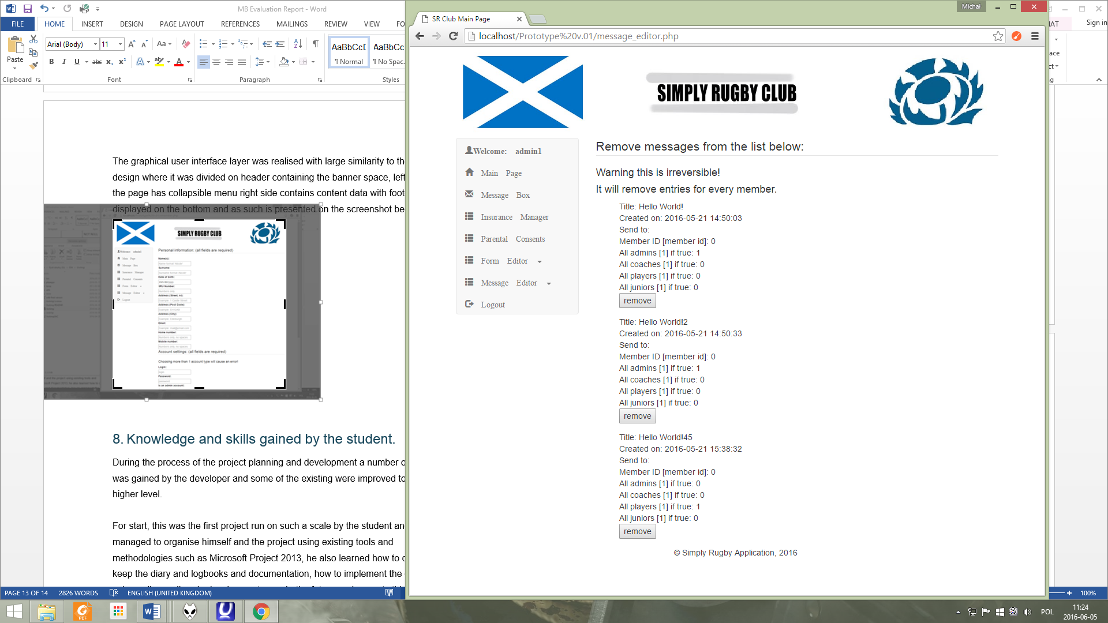  
Lastly there was a post-development issue discovered with the application loading the bootstrap CSS3 file link at the end of the page loading process which was causing a “refresh” effect each time the new page was loaded but it was discovered and measures were taken to avoid it in the future by moving this line  
of code to the top of the each page script between <head></head> tags:  
 **<!-- Bootstrap --> <link href="css/bootstrap.min.css" rel="stylesheet">**

# Knowledge and skills gained by the student.

During the process of the project planning and development a number of skills was gained by the developer and some of the existing were improved to the higher level.  
  
For start, this was the first project run on such a scale by the student and he managed to organise himself and the project using existing tools and methodologies such as Microsoft Project 2013, he also learned how to create and keep the diary and logbooks and documentation, how to implement the design using agile small cycle development runs. In the future assignments this could be improved by applying agile methods to the design stage which would also shorten the project time.  
  
Moreover, programming skills were greatly improved as at the start of the project student considered himself having a strong basics in PHP, HTML5, MySQL and JavaScript and these were taken to at least intermediate level now.  
  
Working with Bootstrap framework gave a much better understanding of the modern mobile and web development techniques, in future it is also worth considering finding a professional tool for managing the code at the implementation stage, as Notepad++ is good for basic tasks or viewing the single script but as the prototype grows it is getting harder to manage the dozens of scripts being opened in tabs which was found problematic at the near-end of prototyping.  
  
While the project was being run it was necessary to carry on research on existing solutions and how to apply them into the project to improve its efficiency and create an effective design. To achieve this student had to find out how to gather data besides the clients brief so the tools were used such as comparing existing solutions to find out its strong and weak sides, making an interview with the client and gathering potential user feedback ideas.  
  
  
Lastly, there is a need to improve the testing techniques and assign more time to them as this is the equally important part of the project and it can discover problematic areas of the design, it would be a good practice to find out about the testing the proposed design before it would be forwarded to the prototyping.

# Project plan execution evaluation.

According to the project plan (available at the next pages) the whole undertaking was completed on schedule and the final submission of the prototype and documentation was at the date set by the college but it was actually completed on week beginning on 16/05/2016 which was correct with the project plan, this gave an extra week to re-evaluate the design and check for additional errors and missing documentation and begin writing this evaluation report.  
From the interesting findings we can see that project planning stage was completed nearly 4 days late as it was initially planned for 12 days, and the design also had a large slack of 11 ¼ days instead of planned 6 but the time was gained by shortening the testing phase and giving less time for the documentation error-proofing which nulled the slack later on.   
The cause of the slack was the need to carry on a wider research and analysis on the assignment topic and in future it can be avoided by assigning more time, asking for more specified data from the client or employing additional personnel and finding efficient techniques which could help with the analyse of the given task.

**This is the original project plan printout:**  
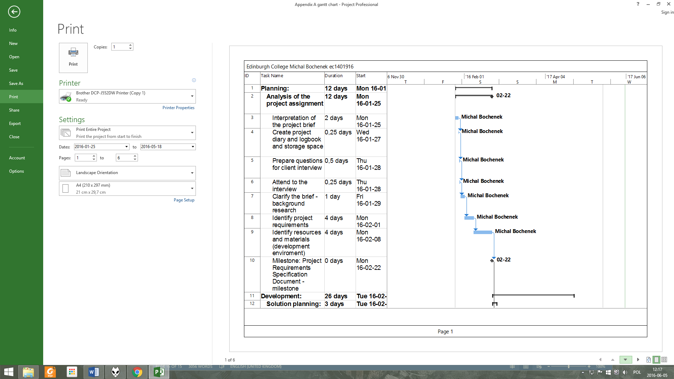

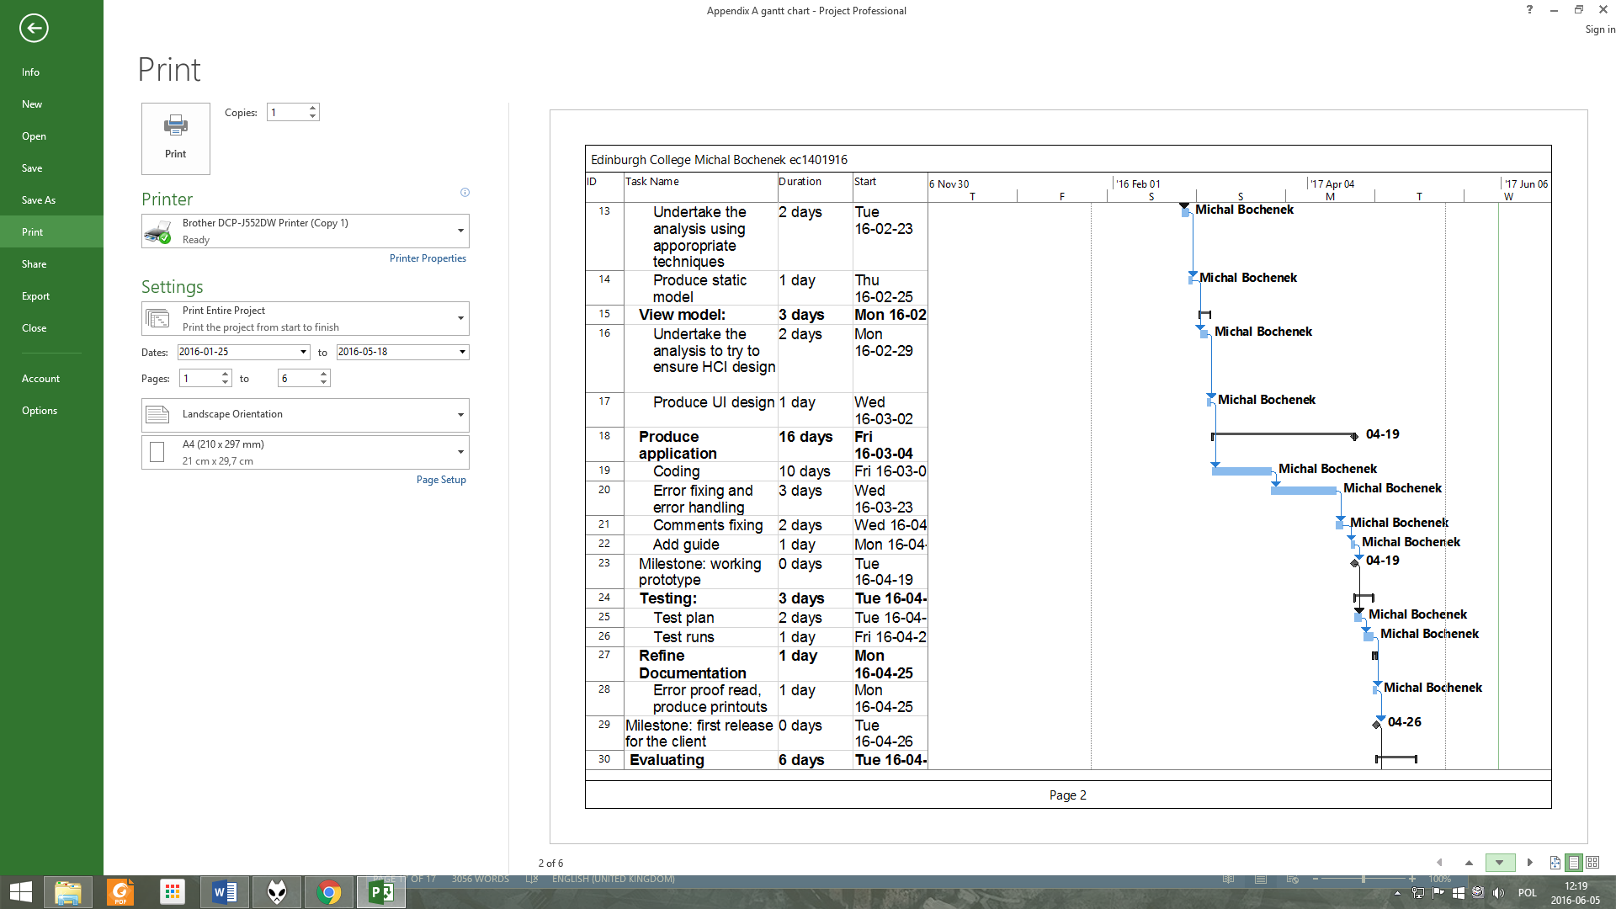  
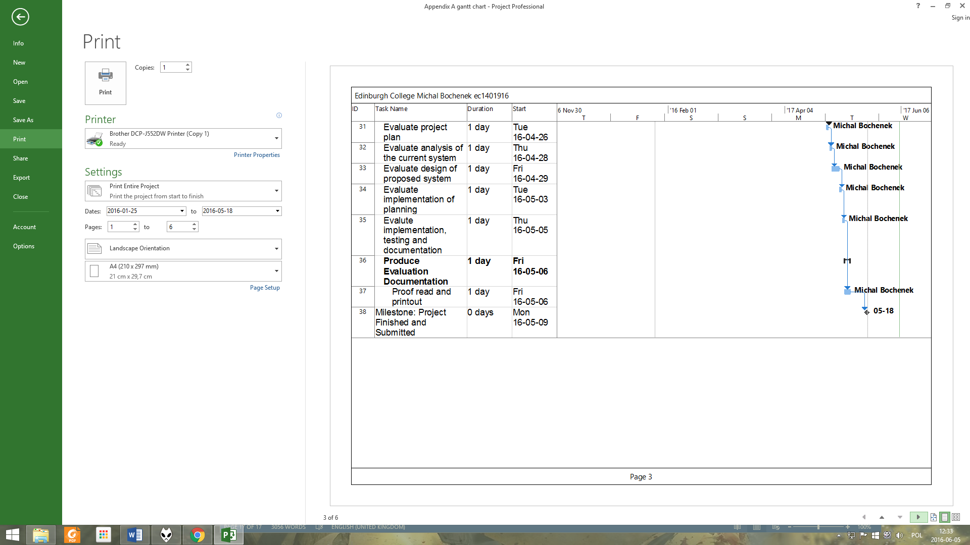

**And this is the simplified project plan designed by basing it on project diary entries where it was noted when each stage started and finished:**